

Topic: EMPLOYEE MANAGEMENT SYSTEM USING JAVA SWING AND MYSQL

PROJECT REPORT

Submitted by:

Surabhi kumari UID: 26MCI10100

Submitted to: Shivam ojha(E20570)
Submitted in partial fulfilment of the requirements for the degree of

MASTER OF COMPUTER APPLICATIONS (MCA) CHANDIGARH UNIVERSITY
University Institute of Computing Punjab, India

BONAFIDE CERTIFICATE
This is to certify that the project report entitled “Employee Management System Using JDBC and Java” has been prepared by Surabhi Kumari, a student of Master of Computer Applications (MCA) at Chandigarh University.

The project has been developed to demonstrate the practical implementation of Java programming, Java Database Connectivity (JDBC), MySQL database management, and Graphical User Interface (GUI) development using Java Swing.

The work presented in this report has been prepared for academic purposes under the guidance of the concerned faculty member.

This project report is submitted in partial fulfilment of the requirements for the degree of Master of Computer Applications (MCA).

Student Signature: Project Supervisor:

Head of Department: Date:

TABLE OF CONTENTS

Chapter 1: Introduction and Background Study PAGE 1 - 2
- 1.1 Project Overview
- 1.2 Problem Definition
- 1.3 Objectives and Scope
- 1.4 Technologies and Libraries Used
- 1.5 Existing System and Proposed Solution

Chapter 2: System Requirements and Design PAGE 3 - 5
- 2.1 Hardware and Software Requirements
- 2.2 System Architecture
- 2.3 Data Flow and Program Workflow
- 2.4 Database Design and Data Model
- 2.5 Functional and Non-Functional Requirements

Chapter 3: Implementation and Analytical Methods PAGE 6 - 8
- 3.1 Program Structure and Object-Oriented Design
- 3.2 Database Connectivity using JDBC
- 3.3 CRUD Operations Implementation
- 3.4 Graphical User Interface Development
- 3.5 Table Display and Row Selection
- 3.6 Input Validation and Automatic Refresh

Chapter 4: Testing, Results and Conclusion PAGE 9 - 12
- 4.1 Testing Methodology
- 4.2 Test Cases and Validation
- 4.3 Results and Analysis
- 4.4 Limitations and Future Scope
- 4.5 Conclusion
- 4.6 Pushing the Project to GitHub
- References

CHAPTER 1: INTRODUCTION AND BACKGROUND STUDY

Project Overview
The Employee Management System is a desktop application that allows an organisation to maintain its employee records in a central database. It is written in Java and uses the Swing toolkit for the graphical user interface and a MySQL database, accessed through JDBC (Java Database Connectivity), for permanent storage. The entire application is contained in a single class, EmployeeManagement, which extends JFrame and is developed in the Eclipse IDE using Java SE 21.
The user interacts with one window that contains an entry form, a row of action buttons and a table of existing records. For every employee the system stores five attributes: employee ID, name, email, department and salary. The four basic database operations – adding, viewing, updating and deleting a record – are available through buttons, and every change is written to the database immediately and reflected in the on-screen table.

Problem Definition
Many small and medium organisations still keep employee details in paper registers or scattered spreadsheets. This approach creates several problems:
    - Records are duplicated, inconsistent or lost, because there is no single authoritative copy.
    - Typing errors such as a blank field or a non-numeric salary are not caught at the time of entry.
    - Finding, correcting or removing a record is slow and depends on manual searching.
    - There is no controlled interface, so any user with file access can accidentally overwrite data.
The problem addressed by this project is therefore to design a simple, reliable and easy-to-use application that stores employee data in a relational database, validates the data before it is saved, and lets a user manage the records without writing any SQL.

Objectives and Scope

Objectives
    - To build a Java Swing graphical interface for managing employee information.
    - To connect the application to a MySQL database using JDBC and perform create, read, update and delete (CRUD) operations.
• To validate user input (empty fields, numeric salary, non-negative salary, valid ID) before

it reaches the database.
    - To use parameterised queries (PreparedStatement) so that the application is protected against SQL injection.
    - To present all employee records in a table and let the user select a row to edit or delete it.

Scope
The system covers the storage and maintenance of basic employee details for a single user on a single computer. It does not include user login, payroll calculation, attendance, reporting or a web or mobile interface; some of these are discussed as future enhancements in Chapter 4.

Technologies and Libraries Used
Table 1.1: Technologies used in the project

Technology | Package / Version | Purpose in the project
Java | JDK 21 (JavaSE-21) | Core programming language of the application
Swing | javax.swing, javax.swing.table | GUI components: JFrame, JPanel, JTable, JTextField, JButton, JOptionPane
AWT | java.awt | Layout managers (BorderLayout, GridLayout, FlowLayout), colours and fonts
JDBC | java.sql | Connection, PreparedStatement, Statement and ResultSet for database access
MySQL | MySQL Server (localhost:3306) | Relational database; schema employee_db, table employee
MySQL Connector/J | JDBC driver JAR | Driver that lets Java communicate with MySQL
Eclipse IDE | Eclipse for Java | Writing, running and debugging the code
Git and GitHub | Version control | Storing and sharing the source code

Existing System and Proposed Solution
Existing system. In the existing manual or spreadsheet-based method, employee details are typed into paper forms or Excel sheets. Data is entered without checks, the same employee may appear more than once, and updating or deleting a record means locating it by hand.
Proposed system. The proposed Employee Management System replaces this process with a database-backed desktop application. Its main advantages are:
    - Centralised storage in MySQL, so there is one reliable copy of the data.
    - Instant validation with clear messages for incorrect or missing input.
    - One-click add, update, delete and refresh operations from a single screen.
    - A confirmation dialog before deletion, which prevents accidental loss of data.
    - Selecting a table row automatically fills the form, which makes editing fast and error-free.

CHAPTER 2:
SYSTEM REQUIREMENTS AND DESIGN

Hardware and Software Requirements
Table 2.1: Hardware requirements

Component | Minimum requirement
Processor | Intel Core i3 or equivalent (1.6 GHz or above)
RAM | 4 GB (8 GB recommended)
Storage | 500 MB free disk space for JDK, MySQL and the project
Display | 1024 × 768 resolution or higher (the window is 900 × 600)

Table 2.2: Software requirements

Component | Requirement
Operating system | Windows 10/11 (also runs on Linux or macOS)
Programming language | Java Development Kit (JDK) 21
IDE | Eclipse IDE for Java Developers
Database server | MySQL Server 8.x running on localhost, port 3306
JDBC driver | MySQL Connector/J added to the project build path
Version control | Git and a GitHub account

System Architecture
Although the program is a single Java class, it follows a clear layered design. The presentation layer consists of the Swing components that the user sees. The application logic layer contains the event handlers and the validation code that decide what happens when a button is pressed. The data access layer uses JDBC to send SQL statements to the MySQL database, which stores the employee records permanently.
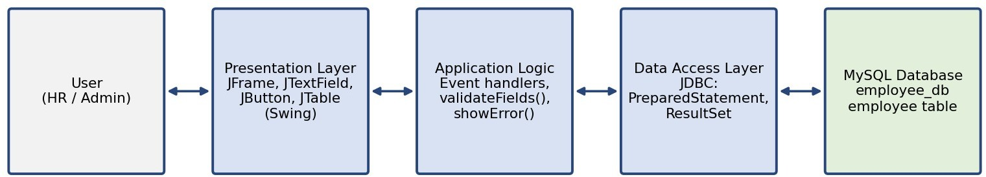
Figure 2.1: Layered architecture of the Employee Management System

Data Flow and Program Workflow
The program follows an event-driven workflow. When the application starts, the constructor builds the window and calls loadEmployees() so that the table is filled from the database. After

that the program waits for the user to act:
    - Add: the user fills in name, email, department and salary and presses “Add Employee”. The input is validated, an INSERT statement is executed, a success message is shown, the form is cleared and the table is refreshed.
    - Select: clicking a row in the table copies its values into the form fields.
    - Update: after selecting a row and editing the fields, “Update Employee” validates the data and runs an UPDATE statement for the chosen ID.
    - Delete: “Delete Employee” asks for confirmation and, if the user agrees, runs a DELETE statement for the chosen ID.
    - Refresh / Clear: “Refresh Table” reloads all records from MySQL, and “Clear Fields” empties the form and removes the row selection.

Database Design and Data Model
The application uses a database named employee_db with a single table, employee. The columns are listed below. The ID is generated automatically by MySQL, which is why the INSERT statement in the program does not supply it.
Table 2.3: Structure of the employee table

Column | Data type | Key / constraint | Description
id | INT | PRIMARY KEY, AUTO_INCREMENT | Unique employee ID
name | VARCHAR(100) | NOT NULL | Full name of the employee
email | VARCHAR(100) | NOT NULL | Email address
department | VARCHAR(100) | NOT NULL | Department of work
salary | DOUBLE | NOT NULL | Salary amount

The table can be created with the following SQL script:
CREATE DATABASE employee_db; USE employee_db;

CREATE TABLE employee (
id INT AUTO_INCREMENT PRIMARY KEY,
name VARCHAR(100) NOT NULL, email VARCHAR(100) NOT NULL,
department VARCHAR(100) NOT NULL, salary DOUBLE NOT NULL
);

Inside the program, the records are held in a DefaultTableModel with the columns ID, Name, Email, Department and Salary. The model is made read-only by overriding isCellEditable(), so all changes must go through the form and the database.

Functional and Non-Functional Requirements

Functional requirements
    - The system shall display all employee records in a table when it starts and when the user presses Refresh.
    - The system shall add a new employee after all fields have been validated.
    - The system shall update the selected employee’s details.
    - The system shall delete the selected employee after the user confirms.
    - The system shall clear the form and the table selection on request.
    - The system shall show an error message when a database operation fails.

Non-functional requirements
    - Usability: a single, uncluttered window with labelled fields and buttons.
    - Reliability: invalid input is rejected before it is sent to the database; resources are closed automatically using try-with-resources.
    - Security: parameterised SQL statements protect against SQL injection.
    - Portability: runs on any operating system that supports Java 21 and MySQL.
    - Maintainability: short, well-named methods, one for each operation.

CHAPTER 3: IMPLEMENTATION AND ANALYTICAL METHODS

Program Structure and Object-Oriented Design
The project is created in Eclipse as the Java project Employeemanagment, with the package employeemanagment and one source file, EmployeeManagement.java (about 340 lines). The class EmployeeManagement inherits from JFrame, so the application window is the object itself. The database settings and the GUI components are encapsulated as private fields, and every operation is a separate private method.
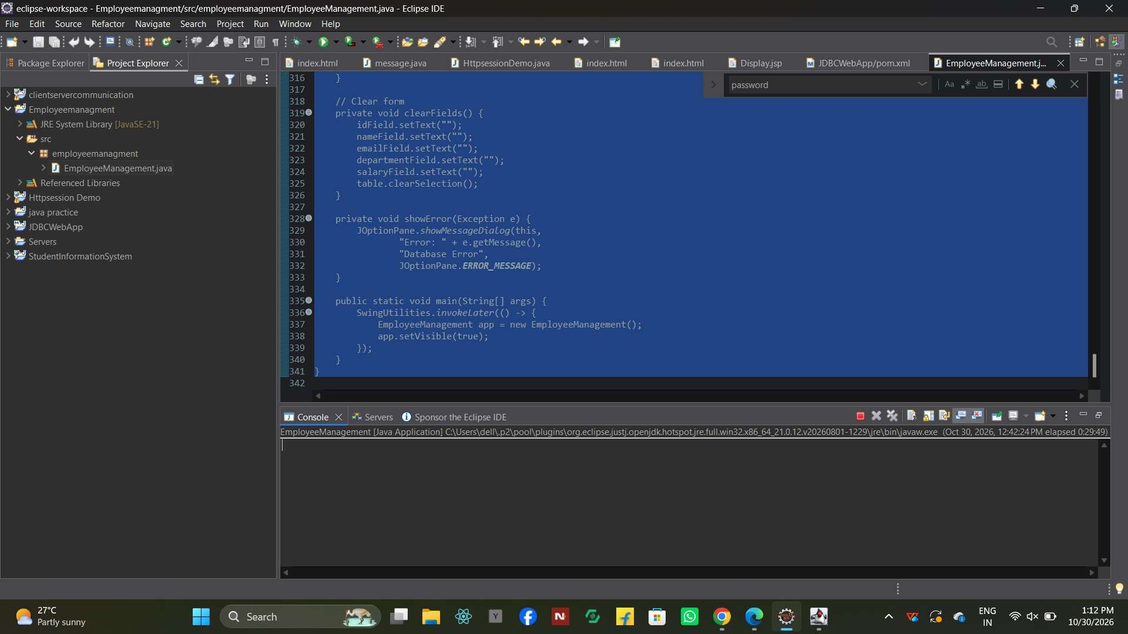
Figure 3.1: Eclipse IDE showing the project structure and the source code of EmployeeManagement.java
Table 3.1: Methods of the EmployeeManagement class

Method | Purpose
EmployeeManagement() | Constructor: builds the window, form, buttons and table, registers listeners and loads the data
getConnection() | Opens a JDBC connection to the MySQL database
loadEmployees() | Reads all rows from the employee table and fills the JTable
addEmployee() | Validates the form and inserts a new employee
updateEmployee() | Validates the form and updates the selected employee
deleteEmployee() | Asks for confirmation and deletes the selected employee
validateFields(boolean) | Checks that fields are filled and that salary and ID are valid numbers
clearFields() | Empties the text fields and clears the table selection
showError(Exception) | Shows database and format errors in a dialog box
main(String[]) | Starts the application on the Swing event thread using SwingUtilities.invokeLater()

Database Connectivity using JDBC
The connection URL, user name and password are stored in private final fields. Every operation obtains a fresh connection from getConnection(), which calls DriverManager.getConnection(). Connections, statements and result sets are declared in a try-with-resources block, so they are closed automatically even if an exception occurs.
private final String url = "jdbc:mysql://localhost:3306/employee_db"; private final String user = "root";
private final String password = "********"; // database password

private Connection getConnection() throws SQLException { return DriverManager.getConnection(url, user, password);
}

The SQLException thrown by any failed connection or query is caught in each method and passed to showError(), which displays the message in a dialog titled “Database Error”.

CRUD Operations Implementation
Create. addEmployee() inserts a new record with a parameterised statement. The salary text is converted to a double before it is bound.
String sql = "INSERT INTO employee "
+ "(name, email, department, salary) VALUES (?, ?, ?, ?)"; try (Connection con = getConnection();
PreparedStatement ps = con.prepareStatement(sql)) { ps.setString(1, nameField.getText().trim()); ps.setString(2, emailField.getText().trim()); ps.setString(3, departmentField.getText().trim());
ps.setDouble(4, Double.parseDouble(salaryField.getText().trim())); ps.executeUpdate();
}

Read. loadEmployees() clears the table model with model.setRowCount(0), runs SELECT * FROM employee, and adds one row to the model for every record in the ResultSet.
Update. updateEmployee() runs UPDATE employee SET name=?, email=?, department=?, salary=? WHERE id=?. The number of affected rows returned by executeUpdate() is checked: if it is zero, the message “Employee ID not found.” is shown.
Delete. deleteEmployee() first shows a JOptionPane.showConfirmDialog(). Only if the user chooses Yes does it run DELETE FROM employee WHERE id=?, again checking the number of affected rows.

Graphical User Interface Development
The window is 900 × 600 pixels, centred on the screen and closes the program when the user exits. It uses a BorderLayout with three regions:

    - North: a heading label “EMPLOYEE MANAGEMENT SYSTEM” with white bold text on a dark blue background.
    - Centre: a panel containing the “Employee Details” form, built with a 5 × 2 GridLayout of labels and text fields, and below it a FlowLayout panel with the five buttons: Add Employee, Update Employee, Delete Employee, Refresh Table and Clear Fields.
    - South: a scroll pane titled “Employee Records” that holds the JTable.
Each button is connected to its method with a lambda expression, for example addButton.addActionListener(e -> addEmployee());, which keeps the event handling short and readable.

Table Display and Row Selection
The table uses a DefaultTableModel whose cells are not editable and a ListSelectionModel set to single selection. A ListSelectionListener copies the selected row into the form, so the user can update or delete a record without typing its ID. The check !e.getValueIsAdjusting() ensures that the code runs only once per click.
table.getSelectionModel().addListSelectionListener(e -> {
if (!e.getValueIsAdjusting() && table.getSelectedRow() != -1) { int row = table.getSelectedRow(); idField.setText(model.getValueAt(row, 0).toString()); nameField.setText(model.getValueAt(row, 1).toString()); emailField.setText(model.getValueAt(row, 2).toString()); departmentField.setText(model.getValueAt(row, 3).toString()); salaryField.setText(model.getValueAt(row, 4).toString());
}
});

Input Validation and Automatic Refresh
The method validateFields(boolean requireId) is called before every add or update. It applies the following rules:
    - If an ID is required (update), a row must have been selected; otherwise the message “Select an employee from the table first.” is shown.
    - Name, email, department and salary must not be empty.
    - Salary must be a valid number and must not be negative.
    - The employee ID, when required, must be a valid positive integer.
    - A NumberFormatException is caught and reported as “Enter a valid number for salary and employee ID.”
After each successful add, update or delete, the program calls clearFields() and loadEmployees(), so the form is reset and the table always shows the current contents of the database without any manual action.

CHAPTER 4:
TESTING, RESULTS AND CONCLUSION

Testing Methodology
The application was tested manually using black-box functional testing: each button and each validation rule was exercised through the user interface and the observed behaviour was compared with the expected behaviour. Both normal inputs and invalid or boundary inputs (empty fields, text in the salary field, negative salary, no row selected, database unavailable) were used. Testing was carried out on Windows with JDK 21, MySQL Server on localhost and the application run from Eclipse.

Test Cases and Validation
Table 4.1: Test cases and expected results

No. | Test case | Input / action | Expected result
1 | Start application | Run with MySQL running | Window opens and existing records appear in the table
2 | Database unavailable | Run with MySQL stopped or wrong password | “Database Error” dialog with the error message
3 | Add valid employee | All four fields filled, salary 45000 | “Employee added successfully!”; form cleared; new row in table
4 | Add with empty field | Leave email blank, press Add | “Please fill in all employee details.”
5 | Non-numeric salary | Salary = abc | “Enter a valid number for salary and employee ID.”
6 | Negative salary | Salary = −5000 | “Salary cannot be negative.”
7 | Select a row | Click a row in the table | All five fields are filled with that row’s data
8 | Update without selection | Press Update with no row selected | “Select an employee from the table first.”
9 | Update valid record | Select row, change department, press Update | “Employee updated successfully!”; table shows new value
10 | Delete without selection | Press Delete with no row selected | “Select an employee from the table first.”
11 | Delete with confirmation | Select row, Delete, choose Yes | Record removed from database and table
12 | Delete cancelled | Select row, Delete, choose No | No change to the data
13 | Refresh table | Press Refresh Table | Table reloaded from the database
14 | Clear fields | Press Clear Fields | All fields empty and row selection removed

Results and Analysis
The application meets the objectives set out in Chapter 1. All four CRUD operations work against

the MySQL database, the table is refreshed automatically after every change, and invalid input is stopped by the validation logic with a clear message before any SQL is executed. Because every statement that uses user input is a PreparedStatement, the program is not vulnerable to SQL injection through the form fields. The row-selection feature makes editing quick, and the confirmation dialog protects against accidental deletion.
For the amount of data handled by a small organisation, loading the whole table with a single
SELECT is fast and the interface stays responsive.
Figure 4.1 shows the application after start-up: the heading, the action buttons and the Employee Records table loaded from the MySQL database.
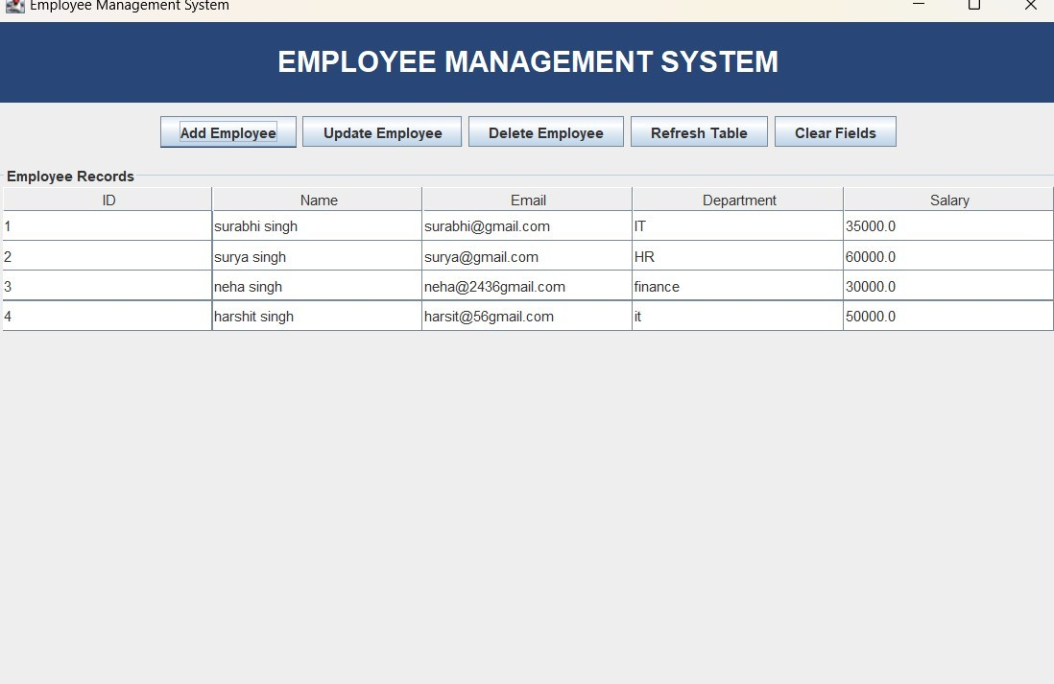
Figure 4.1: Output – main window of the Employee Management System showing the employee records

Limitations and Future Scope

Limitations
    - The database user name and password are written directly in the source code. This is acceptable for a learning project but not for production.
    - There is no user login or role-based access control.
    - The email address is only checked for being non-empty, not for a valid format, and duplicates are not prevented.
    - Database calls run on the Swing event thread, so a very slow database could make the window freeze briefly.
    - There is no search, sorting, filtering or pagination for large numbers of employees.

Future scope
    - Load the database settings from a configuration file or environment variables and add a login screen.
    - Add search and filter options, and export of the data to Excel or PDF.
    - Validate email format with a regular expression and add a unique constraint on the email column.
    - Use SwingWorker or a connection pool for better responsiveness and performance.
    - Add modules for attendance, leave and payroll, or build a web version using Spring Boot.

Conclusion
The Employee Management System successfully demonstrates how a Java Swing front end can be combined with a MySQL back end through JDBC to build a practical record-keeping application. It provides a clean interface, full CRUD functionality, input validation and safe, parameterised database access. While developing the project, concepts such as event-driven programming, layout managers, table models, exception handling, try-with-resources and relational database design were applied in practice. The project provides a solid base that can be extended with security, reporting and additional HR modules.

Pushing the Project to GitHub
The project source code was placed under version control with Git and uploaded to a GitHub repository using the following steps:
    - Create a new, empty repository on GitHub (for example, “EmployeeManagement”).
    - Open a terminal in the project folder (the Eclipse workspace folder
Employeemanagment).
    - Run the commands below, replacing the URL with the address of your own repository.
git init git add .
git commit -m "Employee Management System using Java Swing and MySQL" git branch -M main
git remote add origin https://github.com/<username>/EmployeeManagement.git git push -u origin main

Before pushing, the database password should be removed from the source code (or replaced with a placeholder) so that credentials are not published. After the push, the repository link can be added to this report.
GitHub repository link: https://github.com/<username>/EmployeeManagement

REFERENCES
- Oracle Corporation, “Creating a GUI with Swing”, The Java Tutorials. https://docs.oracle.com/javase/tutorial/uiswing/
- Oracle Corporation, “JDBC Database Access”, The Java Tutorials. https://docs.oracle.com/javase/tutorial/jdbc/
- Oracle Corporation, MySQL Reference Manual and Connector/J Developer Guide. https://dev.mysql.com/doc/
- Oracle Corporation, Java Platform, Standard Edition API Specification (java.sql and javax.swing packages). https://docs.oracle.com/en/java/javase/21/docs/api/
- Herbert Schildt, Java: The Complete Reference, McGraw-Hill Education.
- Eclipse Foundation, Eclipse IDE Documentation. https://www.eclipse.org/documentation/

